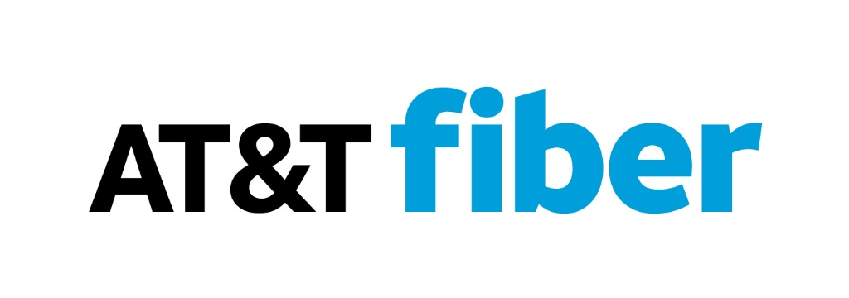

AT&T Fiber Optic Cable Installation Notification

  - Important Information for Homeowners
Dear Homeowner,
We are pleased to inform you of upcoming improvements to your neighborhood’s connectivity. In the coming weeks, AT&T will be upgrading its network infrastructure by installing state-of-the-art fiber optic cables. This important work will help bring faster, more reliable internet services to your community.

What to Expect
- All installation activities will occur within the existing easements and utility or road rights of way. While some work may take place on or near your property, it will remain within these designated areas. This work will sometimes require access to our network that could include the need to trim trees or to dig on or near your property. We will always do our best to minimize any disruptions to you.
- Soon, you will notice colored flags and/or painted markings on or near your property. These are used to locate and identify existing underground utilities in accordance with safety regulations. Please do not disturb these markers—they are temporary and necessary for the installation process.
- If you have a sprinkler system, dog fence or other underground items in the easement area or right of way, please mark them with white or pink flags. These will not be marked by OUPS/811.
- If any area of your property is disturbed or damaged because of this work, rest assured that our crews are committed to restoring the site to the same—or better—condition as before.
- Work is scheduled to begin within two weeks from the distribution of this notification and is expected to be completed, including all restoration efforts, within one month of the project start date.
- Once installation is complete, AT&T Fiber service will become available to your home within one month, offering you access to enhanced internet speeds and reliability.

The project will be completed in phases:
- Phase one includes boring/digging and placing fiber optic cables and structures to house splice and termination points, including serving terminals that will supply residential service. This will also include any restoration work.
  - AT&T hires contract suppliers to perform the construction work which includes any digging, boring, fiber optic cable placing, and restoration. To speak directly to the AT&T Inspector who will be overseeing the construction work, please reach our AT&T Inspector________________________________________ at _________________________________.
- Phase two will include splicing (making the connections). AT&T employs local technicians to perform the work of splicing fiber and installing hardware.
- Phase 3 will complete the project by installing state-of-the-art services to individual homes as requested by customers. This work is also performed by local AT&T employees.
You will see vehicles and equipment belonging to our Contractor as well as AT&T in your neighborhood throughout the duration of the project.
We sincerely appreciate your patience and cooperation as we bring this exciting upgrade to your community. Our team of local employees, including dedicated inspectors and managers, are committed to your satisfaction. Should you have any questions or concerns regarding this project, please contact Peggy Johnson on our AT&T Customer Care team at 1-877-780-5422 or visit our website (www.att.com) for more information.
Thank you for choosing AT&T.
Sincerely,
The AT&T Team
