
MENTOR POLICE DEPARTMENT

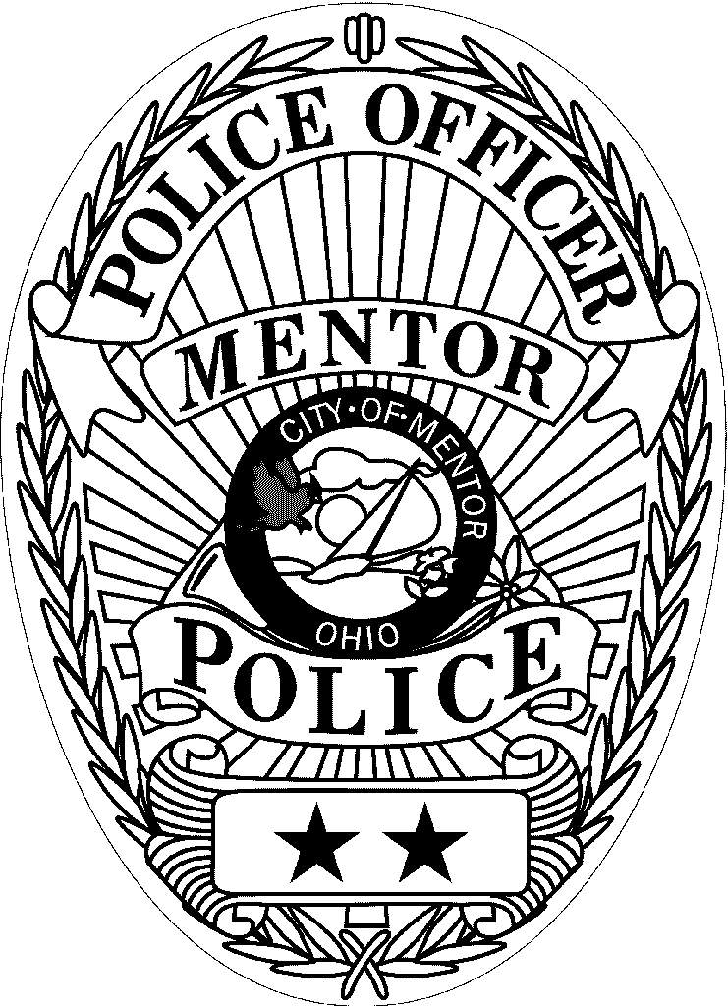

Bicycle Helmet

ORDER FORM

The Mentor Police Department, in cooperation with the Greater Cleveland Safe Kids Coalition, and University Hospital Rainbow Babies and Children’s Hospital are offering bicycle helmets at a significantly reduced cost!
The helmets are name brand helmets and are tested to exceed the stringent bicycle helmet standards set by the American Society of Testing and Materials (ASTM) and the American National Standards Institute (ANSI). They carry a Severe Damage Service and if damaged in an accident, the manufacturer will inspect and replace the helmet free of charge.
In order to offer the incredibly low price of $8.50 per helmet, the Graphics and Color of helmets are random and cannot be chosen. Helmets cannot be exchanged or returned.

Administrative use only.
Name:___________________________________________________
PLEASE PRINT
Address:_________________________________________________
________________________________________________________

Home/Work Phone:__________________________Cell Phone: _______________________
Please place completed order forms and check or money order in an envelope and send or deliver to Mentor Police Department, c/o Crime Prevention, 8500 Civic Center Blvd. Mentor, Ohio 44060. A personal check, bank check, or money order made out to CITY OF MENTOR must accompany the helmet orders. Please DO NOT SEND CASH.
Returned checks because of closed account, insufficient funds etc. will be charged $20.00. Helmet fitting and delivery will be at the Police Department and will take 2-3 weeks.
Notification will be made by telephone.
HOW TO ORDER THE CORRECT SIZE: To get a “proper fit”, measure your child’s head one inch above the eyebrows and use the chart below. The helmets come with foam pads to “fine tune” the helmet fit.
Size | Male | Female | Price | Total Qty | Total Cost
TODDLER  Recommended age: under age 5  20” – 21 ¼” |  |  | $8.50
CHILD  Recommended age: 4-8  20 ½” – 22 ¾” |  |  | $8.50
YOUTH  Recommended age: 8 & up  21 ¾” – 22 ¾” |  |  | $8.50
ADULT S/M  22 ½” – 23 3/8” |  |  | $8.50
ADULT M/L  23 1/8” – 24 3/8” |  |  | $8.50

Make checks payable to: CITY OF MENTOR

